SOFTWARE ENGINEERING LAB REPORT
Version Control with Git and GitHub

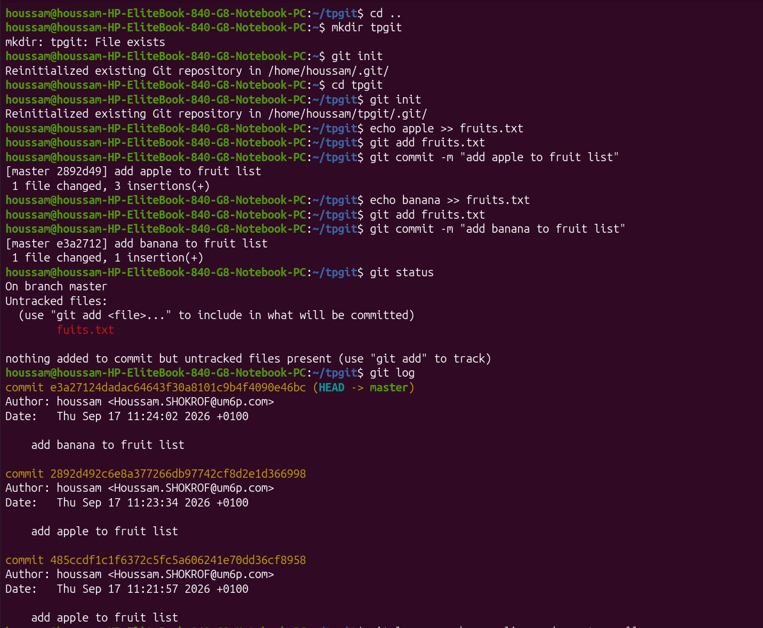
Figure 1. Repository initialization, first commits to fruits.txt ("add apple", "add banana"), git status showing the untracked fuits.txt file, and the resulting commit history from git log.

4. Part 2 — Branching
The second exercise focused on branches. Two new branches, vegetables and sauce, were created from master with git branch / git switch (and git checkout -b as an alternative). On each branch, a dedicated file was created and populated with independent commits:
- vegetables branch → vegetables.txt: "botatos", "tomato", "carottes".
- sauce branch → sauce.txt: "algerienne", "andalous".
Along the way, a few typical beginner mistakes were made and corrected: attempting cd vegetables on a branch name instead of a directory, calling git branch vegetables followed by git checkout -b vegetables (which fails because the branch already exists), and mistyping git add sauce.txt with a wrong filename (algerienne.txt). Each error message was read and used to fix the command.
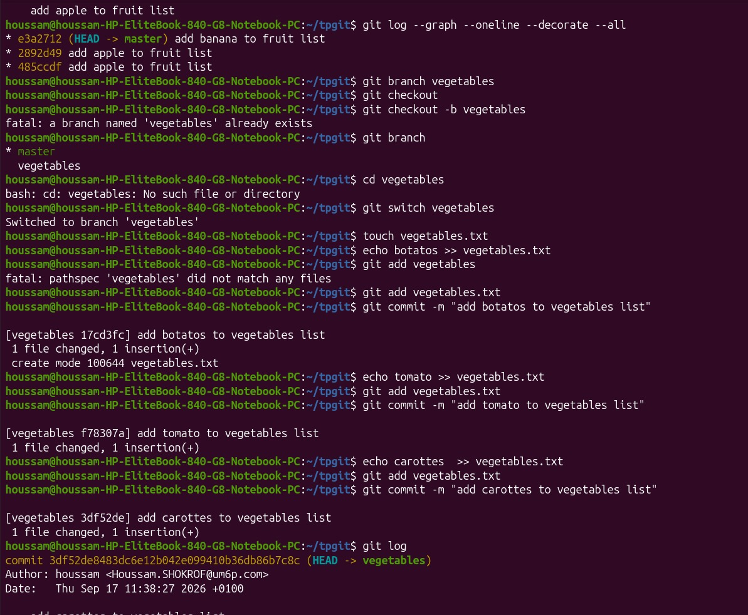
Figure 2. Creating the vegetables branch, switching to it, and committing "botatos", "tomato" and "carottes" to vegetables.txt.
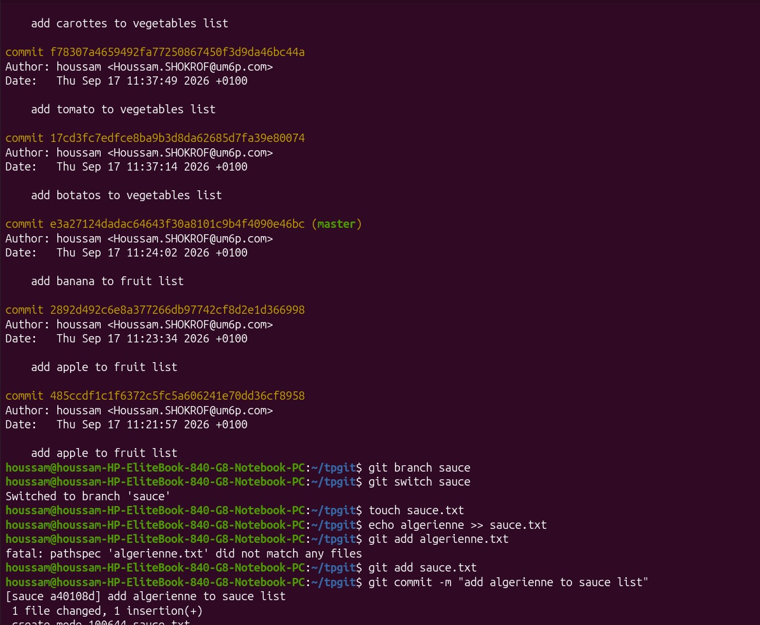
Figure 3. git log continued on the vegetables branch, then creating the sauce branch and committing "algerienne" to sauce.txt (after correcting a mistaken filename in git add).
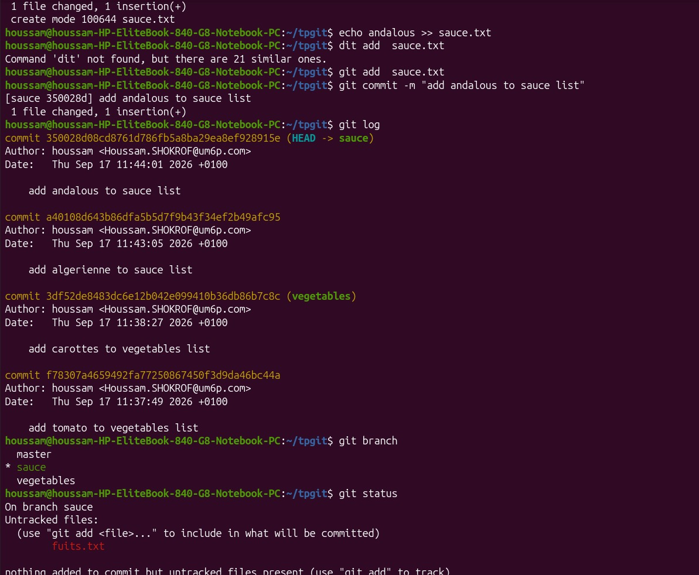
Figure 4. Adding "andalous" to sauce.txt (after mistyping dit add instead of git add), reviewing the full log, and listing all local branches with git branch.

5. Part 3 — Merging Branches
With the vegetables and sauce branches each containing their own commits, the next step was to bring the work back together. From the vegetables branch, git merge sauce was run, resulting in a fast-forward merge. Then, after switching to master (correcting a typo, git switch to master, which is not valid syntax — the intended command is simply git switch master), git merge vegetables merged both feature branches into master in a single fast-forward update.
Because no branch had diverged independently, Git was able to fast-forward the branch pointer rather than creating a merge commit — all three branches (master, vegetables, sauce) ended up pointing at the same final commit.
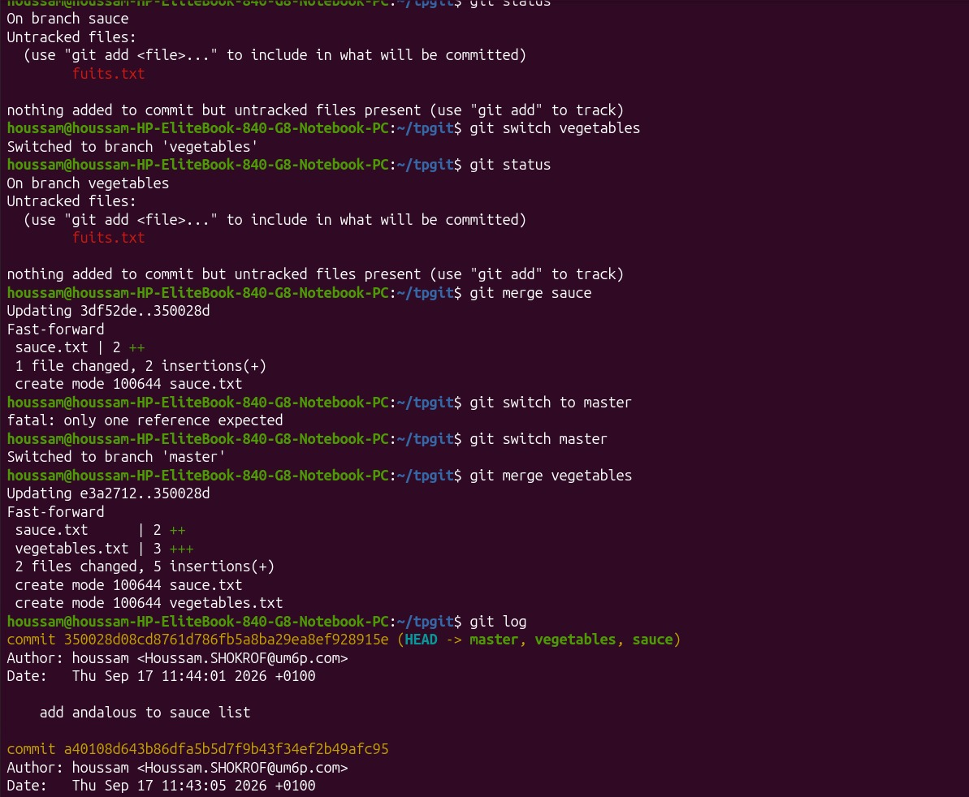
Figure 5. Merging sauce into vegetables and vegetables into master, both resolved as fast-forward merges; the resulting git log shows master, vegetables and sauce all pointing at the same commit.
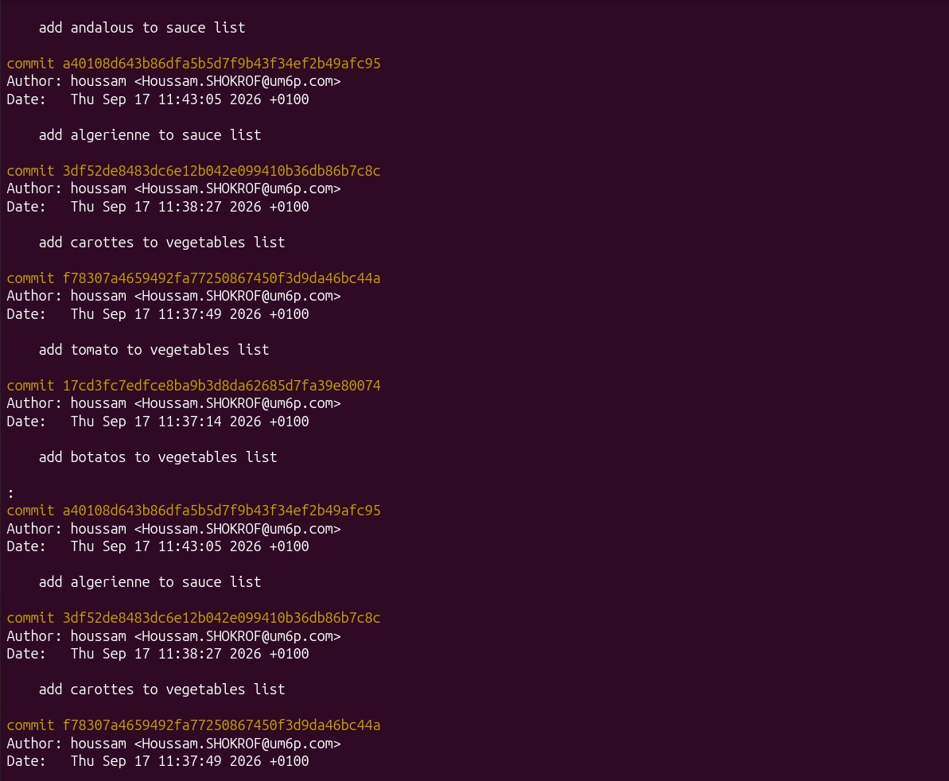
Figure 6. Full commit history after the merge, listing every commit from the initial "add apple" through to "add andalous to sauce list".
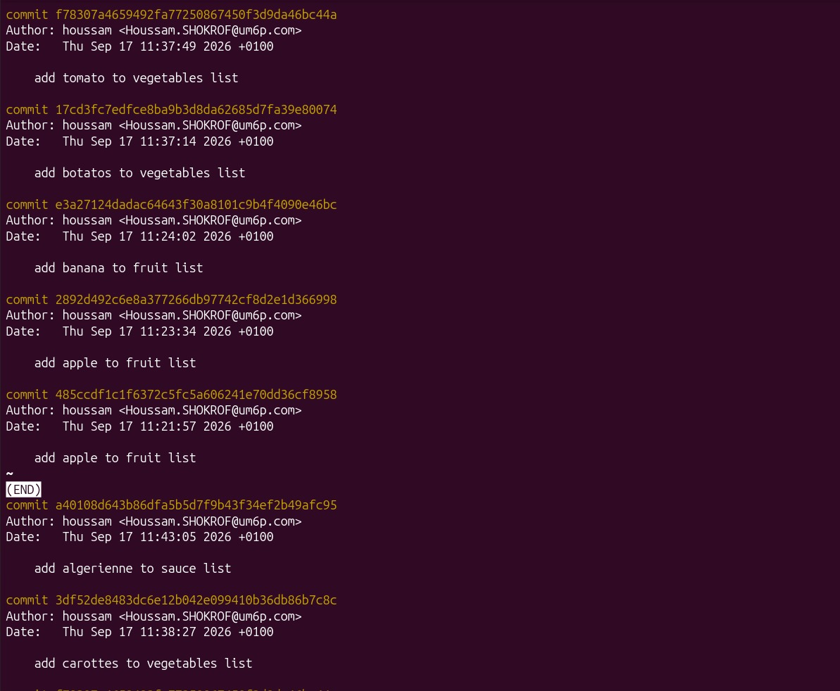
Figure 7. Continued review of the merged history using git log, confirming that the vegetables and sauce commits are now part of the same line of history as master.
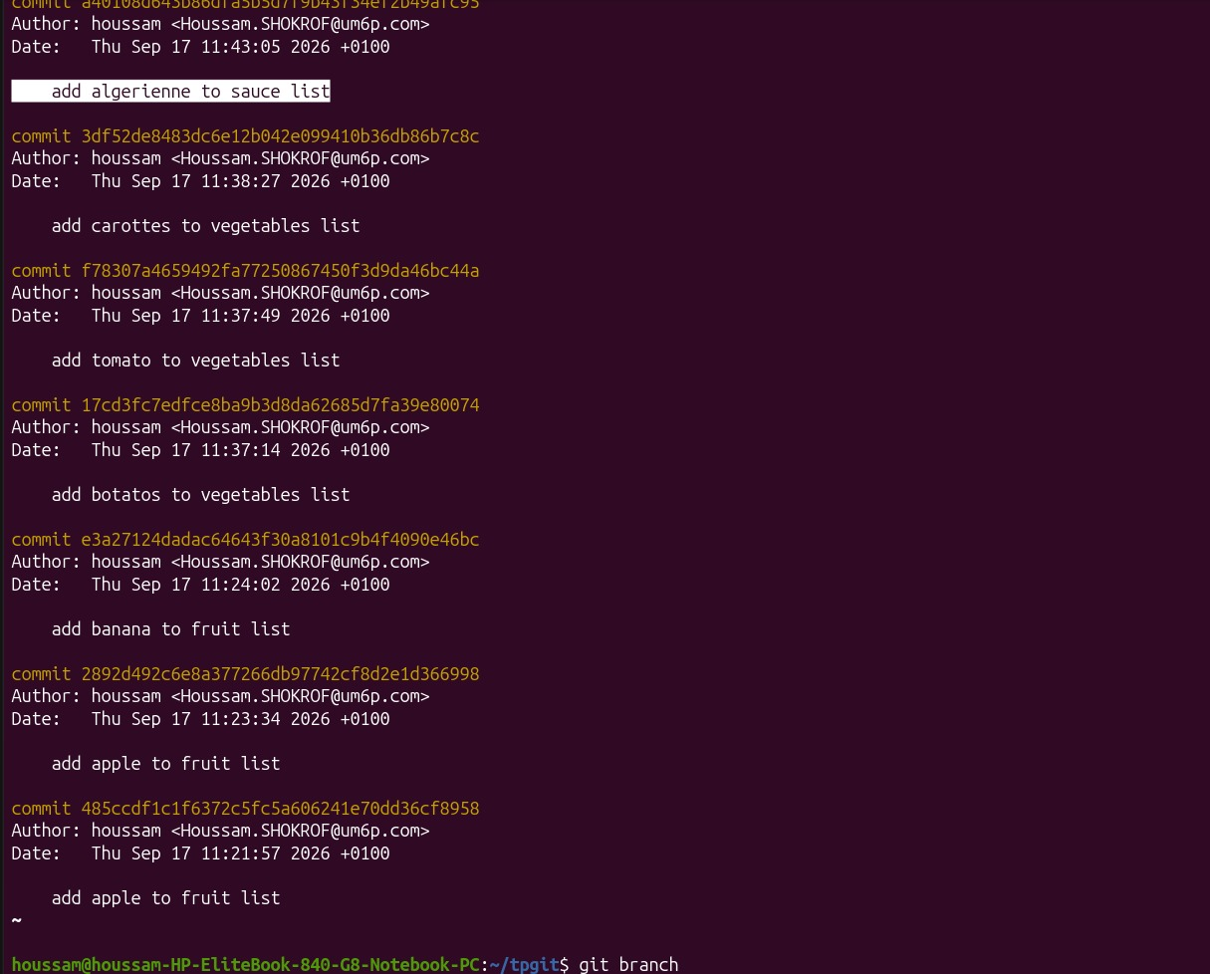
Figure 8. Scrolling through the merged log with the pager, and the branch list showing master, sauce and vegetables converged after the merges.

6. Part 4 — Connecting to a Remote Repository on GitHub
The local repository was then linked to GitHub. The first attempt, git remote add origin https://github.com/THE FOOL/..., failed because the URL was malformed (a placeholder/incorrect username), producing a usage error and then a "could not read from remote repository" error once a push was attempted.
After correcting the remote URL to the actual GitHub account (houssamshokrof8-pixel) and re-adding the origin remote, a git push -u origin master still failed because the local default branch was named master while the remote expected main — a common mismatch between Git's historical default branch name and GitHub's current default (main).
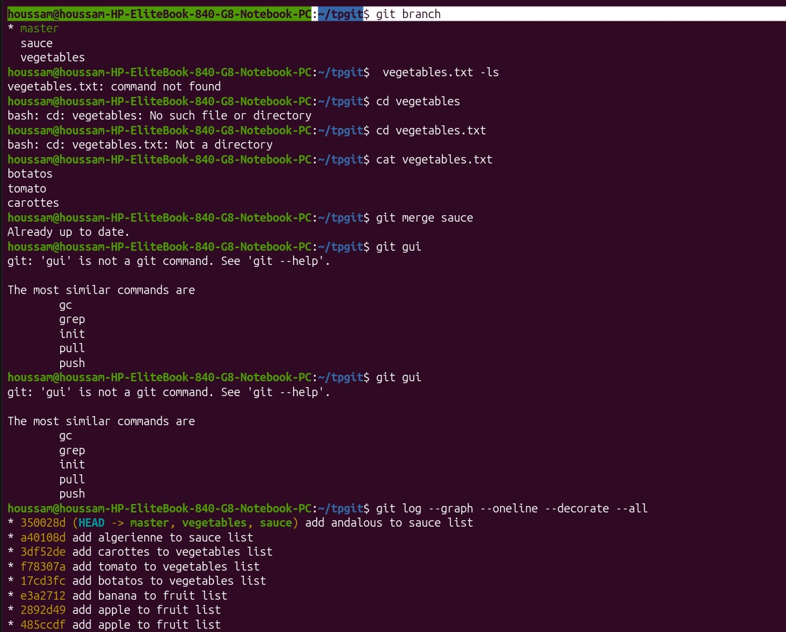
Figure 9. Listing local branches and the full commit graph (git log --graph --oneline --decorate --all) before configuring the GitHub remote.
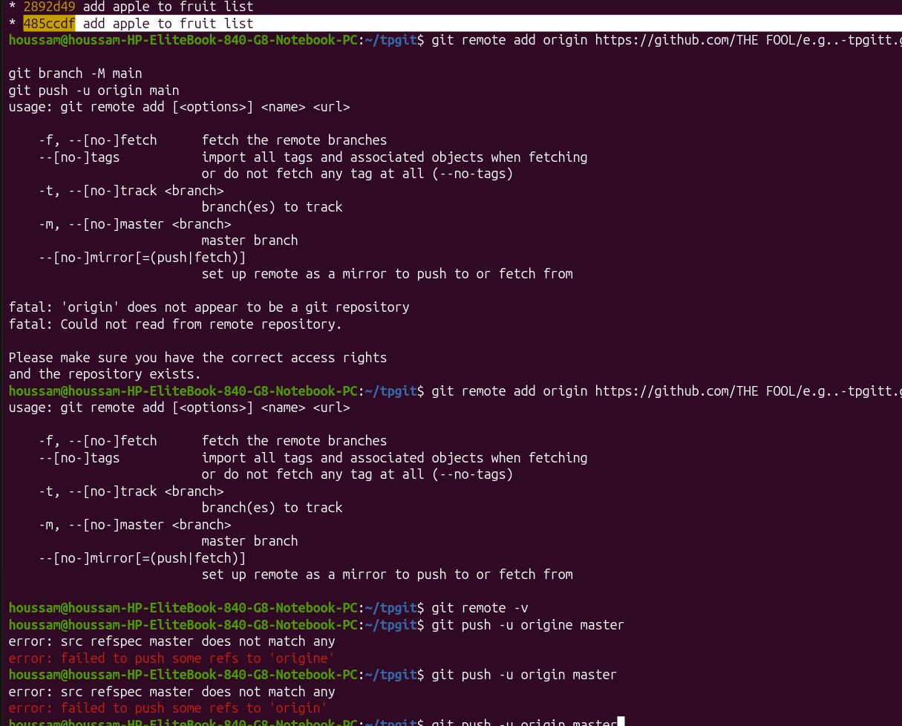
Figure 10. First (failed) attempt to add a GitHub remote with an incorrect URL, and the resulting "fatal: 'origin' does not appear to be a git repository" error.
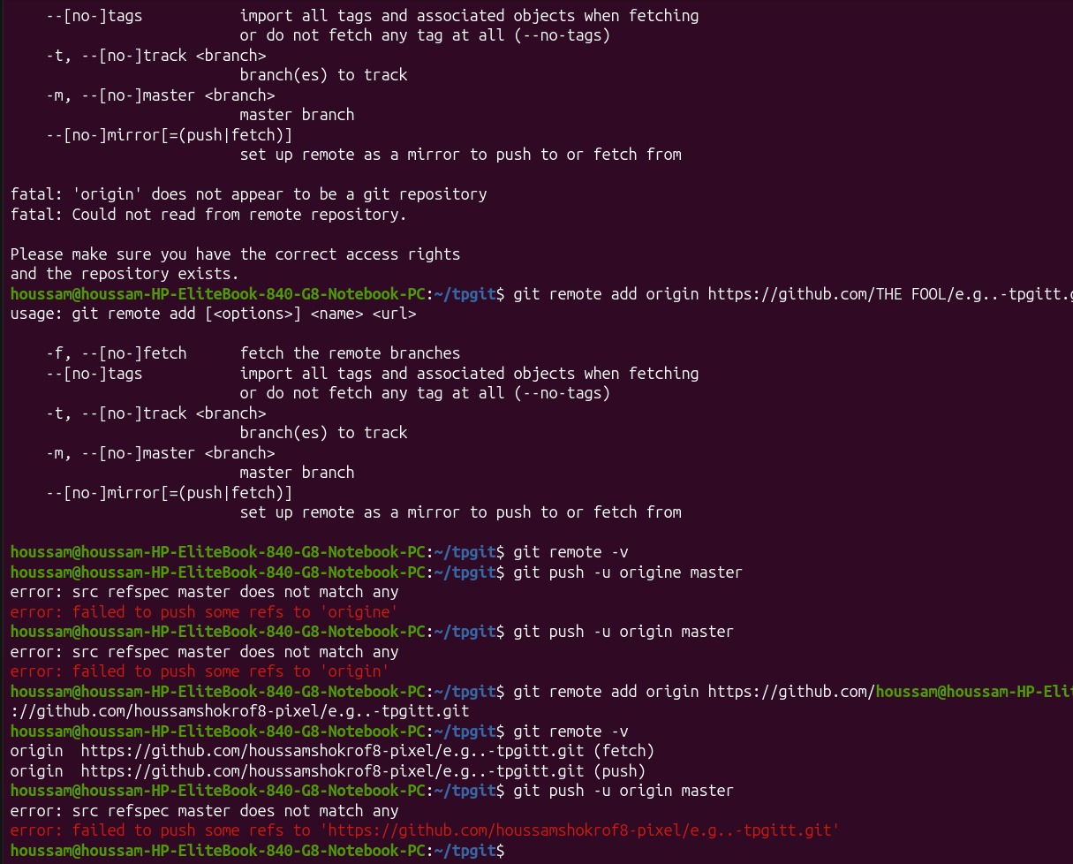
Figure 11. Diagnosing the problem with git remote -v, then re-adding the origin remote with the correct URL for the houssamshokrof8-pixel GitHub account; the push still fails because the local branch (master) does not match the remote's expected branch (main).
The remaining fix was to authenticate the GitHub CLI. The account was logged out and back in with gh auth login, choosing HTTPS as the Git protocol and completing a browser-based, one-time-code login. gh auth status then confirmed an active, authenticated session for houssamshokrof8-pixel. From there, git push -u origin main succeeded, publishing the tpgit repository to GitHub for the first time.
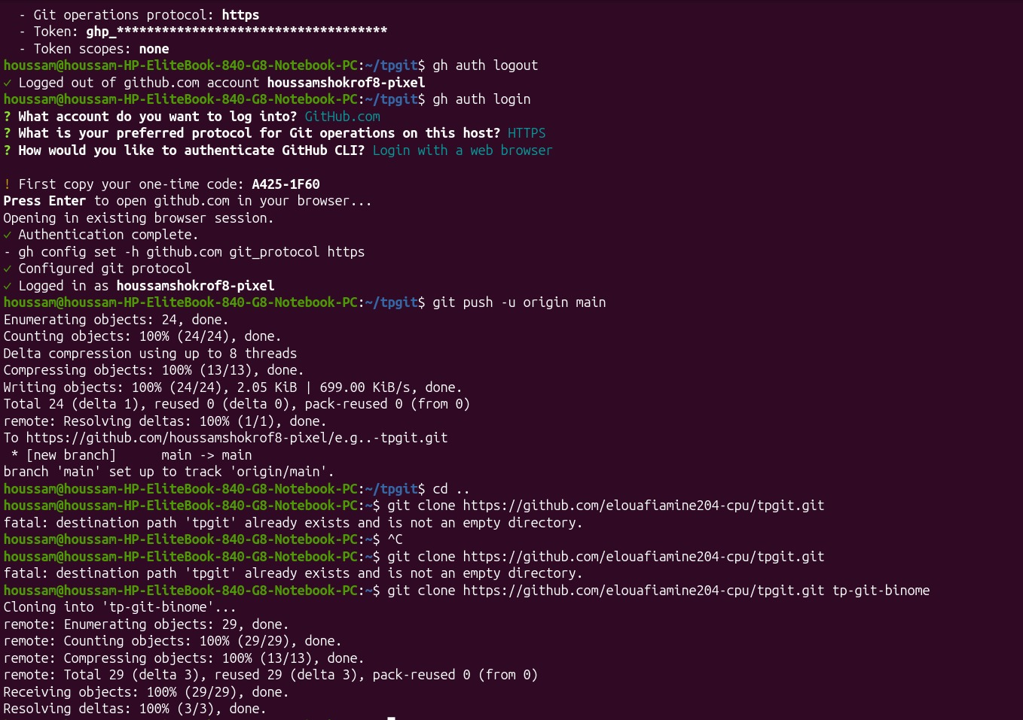
Figure 12. gh auth status showing the previous session, followed by gh auth logout / gh auth login (HTTPS, browser-based one-time-code authentication) and a successful git push -u origin main creating the main branch on GitHub.

7. Part 5 — Cloning and Collaborating with a Partner
To simulate a collaborative workflow, a second, independent clone of the shared repository was created in a separate local folder, tp-git-binome, using git clone (a first attempt failed because a folder named tpgit already existed and was not empty).
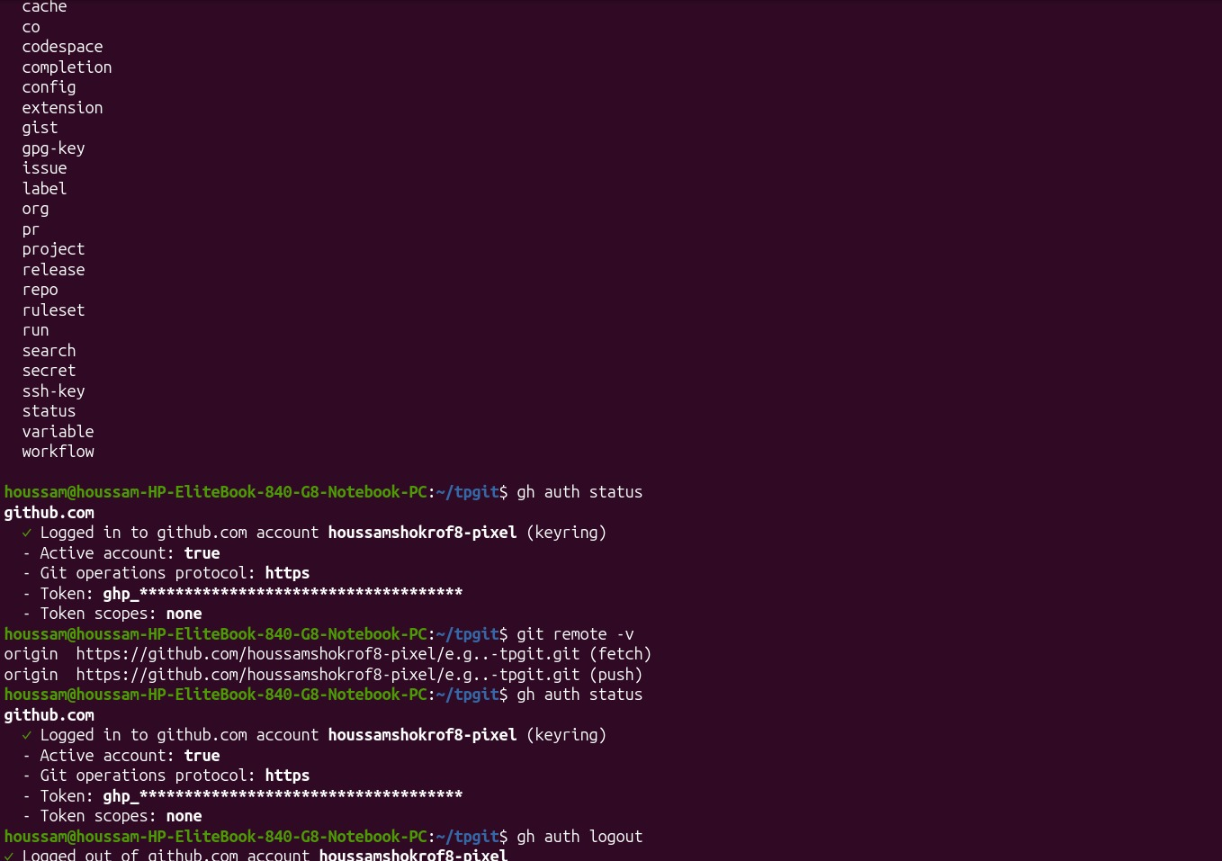
Figure 13. Reviewing GitHub CLI command categories and confirming authentication with gh auth status and git remote -v before cloning.
This second clone, tp-git-binome, pointed at a repository owned by a lab partner (elouafiamine204-cpu). Its history already contained commits from that partner — "Added spice", "Added carrot", "Added a fifth fruit", "Added potato", "Added onion", "Added ketchup", "Added mayo" — plus a merge commit, showing that the partner had been working on the same shared project independently.
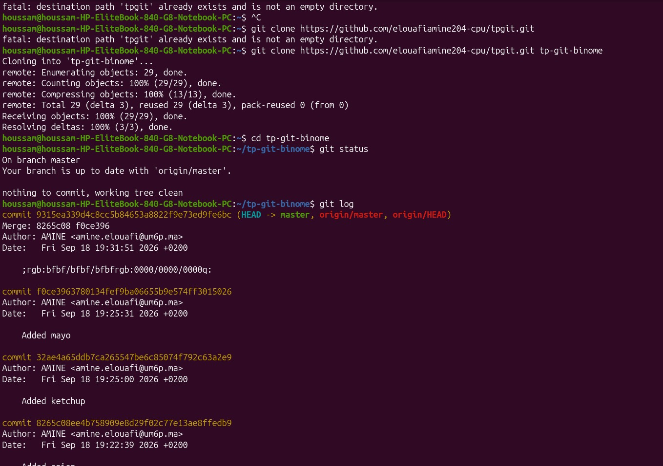
Figure 14. Cloning the partner's repository into tp-git-binome and reviewing its commit history, which already contains the partner's contributions and a merge commit.
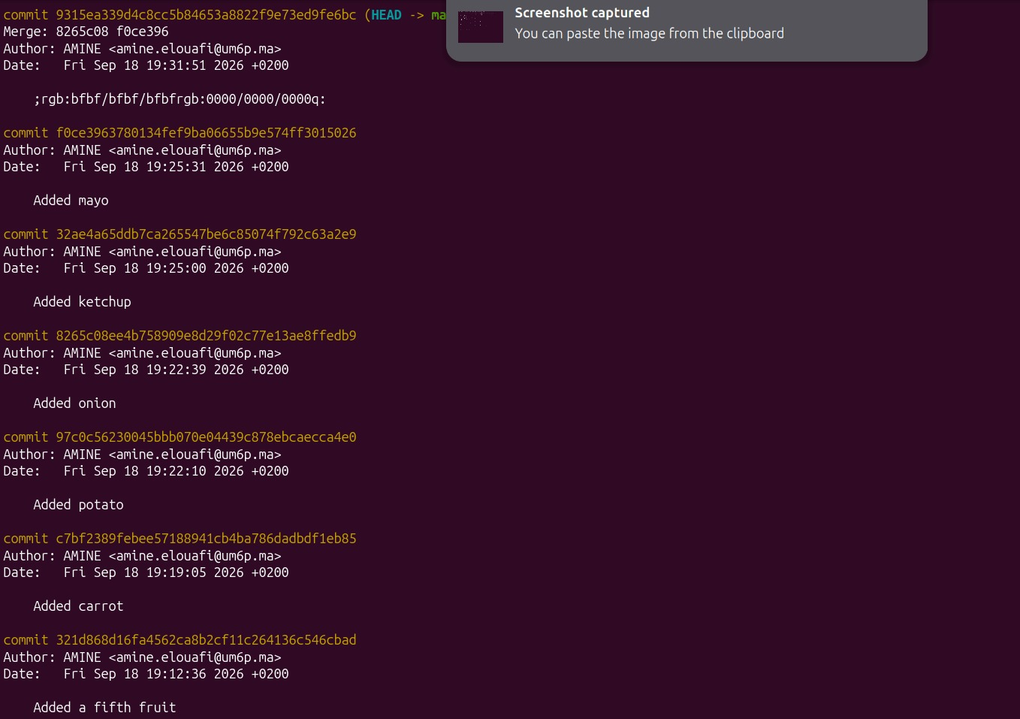
Figure 15. Continuing to review the partner's commit history ("Added a fifth fruit", "Added carrot", "Added potato", "Added onion", "Added ketchup", "Added mayo").
A new branch, herbs, was created inside the partner's clone to add further content (basil, mint) to herbs.txt — again encountering and recovering from a shell typo (git co;;it instead of git commit). After committing on the herbs branch, it was merged into master with a fast-forward merge, and git status showed the local master branch was now two commits ahead of origin/master.
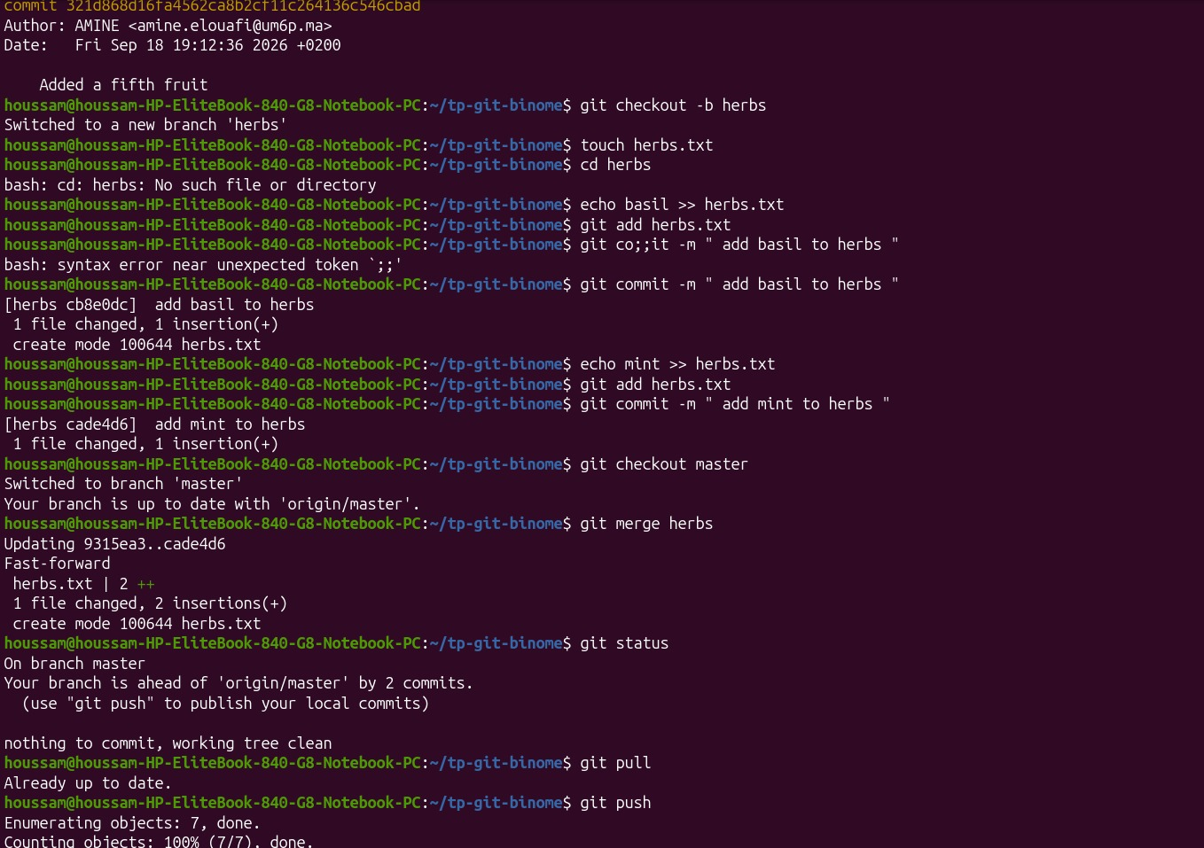
Figure 16. Creating the herbs branch, committing "basil" and "mint" to herbs.txt, merging herbs into master (fast-forward), and confirming with git status that master is ahead of origin/master by two commits.
Before pushing, git pull was run to make sure no new remote changes were missed ("Already up to date"), and the two herbs commits were then published with git push. Switching back to the original tpgit clone and running git pull there retrieved a new file, spices.txt, that had been pushed independently by the partner, confirming that changes now flow both ways between the two collaborators through the shared GitHub repository.
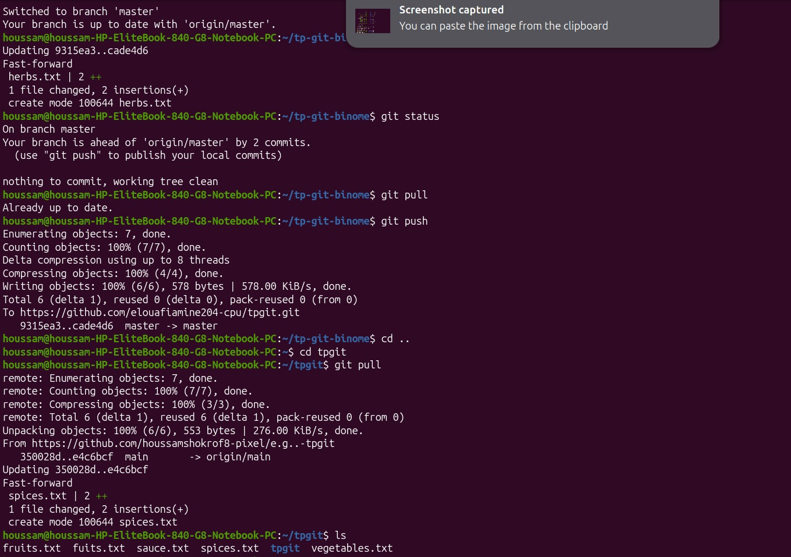
Figure 17. Pulling and pushing the herbs branch from tp-git-binome, then switching back to the original tpgit clone and pulling the partner's new spices.txt file from origin/main.

8. Part 6 — Further Edits and Multi-Clone Synchronization
In the original tpgit clone, fruits.txt was extended with two more entries ("dragonfruit", "hablook") via echo, git add and git commit, each change verified with cat. The two local clones (tpgit and tp-git-binome) were then kept in sync by alternating git pull and git push between them, mirroring how two collaborators repeatedly exchange updates through a shared remote.
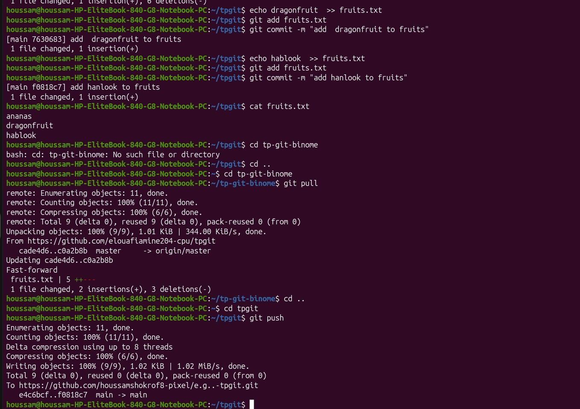
Figure 18. Adding "dragonfruit" and "hablook" to fruits.txt, then synchronizing the two local clones: pulling the latest fruits.txt into tp-git-binome and pushing it back to origin from tpgit.
The final set of edits used sed to perform in-place text substitutions and line deletions on vegetables.txt: replacing "botatos" with "cucumber" (sed -i 's/botatos/cucumber/g'), deleting a line (sed -i '2d'), and appending "latus" and "garlic" with echo. A git pull at this point failed with "Could not resolve host: github.com" — a temporary loss of network connectivity — which was worked around by switching to the tp-git-binome clone, where the pull succeeded once connectivity returned, fast-forwarding vegetables.txt.
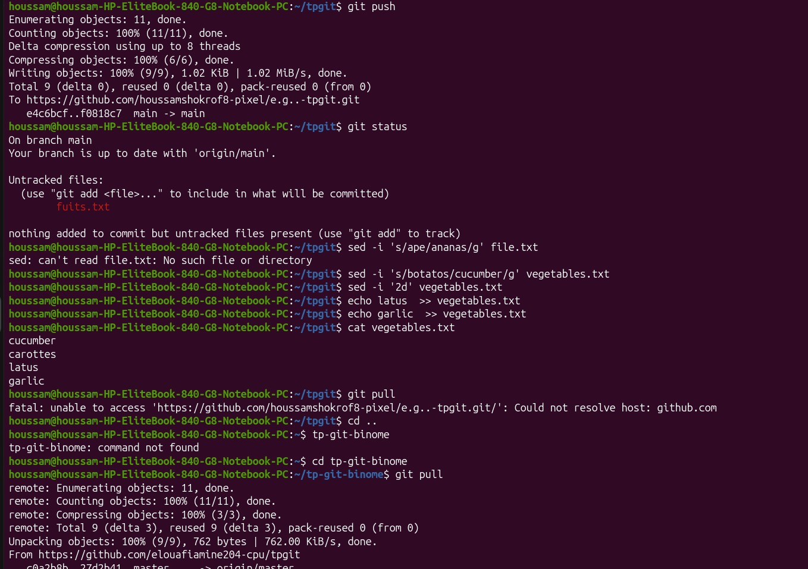
Figure 19. Editing vegetables.txt with sed (substitution and line deletion) and echo, then a failed git pull ("Could not resolve host: github.com") followed by a successful pull from the tp-git-binome clone.
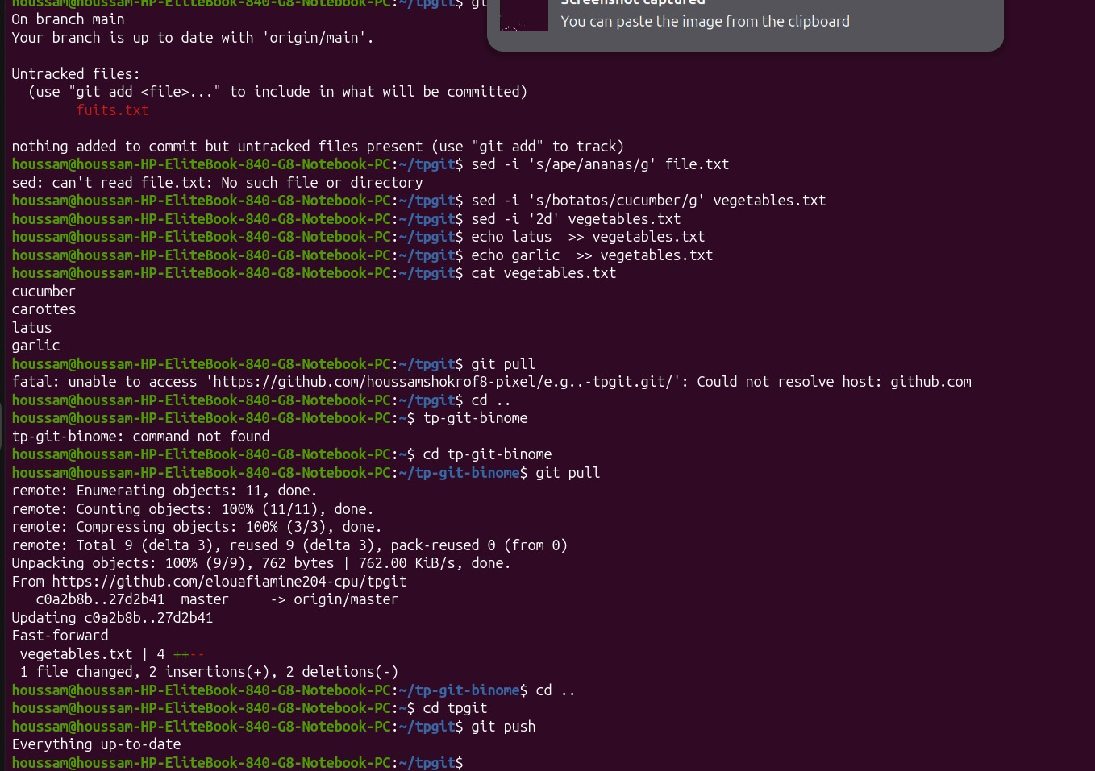
Figure 20. Completing the fast-forward pull of vegetables.txt in tp-git-binome, then returning to tpgit where git push reports "Everything up-to-date", confirming both clones are fully synchronized.
.

